

Sri Lanka Institute of Information Technology

**Electronic Shop System**

Project Proposal

Information Technology Project (IT2080)

2018

Project ID :- ITP-2018-MLB-G1-15

Submitted by:

1. IT16178700 – D.I.K. Rajapakshe
2. IT17018760 – M.P.P. Shamil
3. IT16067370 – Rathnayaka M.H.K.R
4. IT17015172 – Subasinghe R.S.R.M.D

Submitted to:

Name of the supervisor

Ms. Uthpala Samarakoon

…………………………..

(Supervisor’s signature)

Date of submission

7/15/2018

**Abstract**

For our project, we decided to choose our client Mr. Edirisoriya who is the owner of the Micro Electronics which is located in Matara. This project is aimed at developing an Automated Electronic Shop System Software that is optimize employee workload. The general nature of the business is selling and manufacturing of electronic spare parts. This project was selected as they were in need of a comprehend automated system to manage and replace human power which consumes less time and fewer resources having a higher accuracy.

Moreover, the procedure involved in the electronic shop is difficult to handle where they currently use a manual file base system for management and maintains of information. This current process requires bill books and other books to record product data and salary details. So, they cannot get decision immediately and wasting their workable hours for manually maintaining records. The primary need of the client was to store data efficient in a well-ordered manner, restrict employee works and reporting capabilities. As a solution we decided to develop desktop application to solve their problems including all the client requirements.

To build that we are using java as the programing language, MySQL database and Apache Tomcat Server. The source code will be created in the software Eclipse IDE.

The proposal provides a useful insight about the project carried out as a whole. It provides details on the requirement specification, analysis, application modeling, design, testing and implementation future scope and limitation of the application development. The importance of this system to organization is Efficient data access, Restricting unauthorized access and Concurrent access.

The software helps them maintain day to day transaction in computer and it could lead business to its success.

# Table of Contents

**Abstract**………………………………………………………………………………………2

**Table of Contents……………………………………………………………………......**3

**1.** **Introduction………………………………………………………………………….**4

**2.** **Objectives****………………………………………………………………………………6**

**3.** **Procedure****………………………………………………………………………………8**

**3.1** **Flow of the Project****………………………………………………………………………….8**

**3.2** **Project Plan****………………………………………………………………………………..10**

**4.** **Personnel and Facilities****……………………………………………………….11**

**5. TECHNOLOGIES………………………………………………………………………...12**

**6.** **Software and Hardware Requirements****…………………………………13**

**7.** **Budget****…………………………………………………………………………………...14**

**8. REFERENCES…………………………………………………………………………….15**

**Appendix A****…………………………………………………………………………………...16**

**Table of Figures**

**Figure 1.1.a High Level Diagram….…………………………………………………………....5**

**Figure 3.2.a Gantt Diagram…………………………………………………………….……...10**

# Introduction

Micro Electronics is an electric shop located in Matara. It was started in the month of September 2017. And also, it is one of the leading and fast-growing business in that area. There are five employees including the manager, cashier, employees and security officer. Currently this shop is

using manual method to manage larger amount of information. So, they face problems in maintaining registers as well as complicated searching, editing, updating, less accuracy in calculations etc... And those are very time-consuming process.

Since they have high competition in this business field they request a system that can solve above problems at the conference we had. So, we decided to develop a system reduce complicated manual work by computerize employee, stock, product, customer details etc. And handle the process easily in a secure manner.

So, in the future with the help our system they will be able to handle current problems and reach their business goals successfully.

Figure 1.1.a High Level Diagram 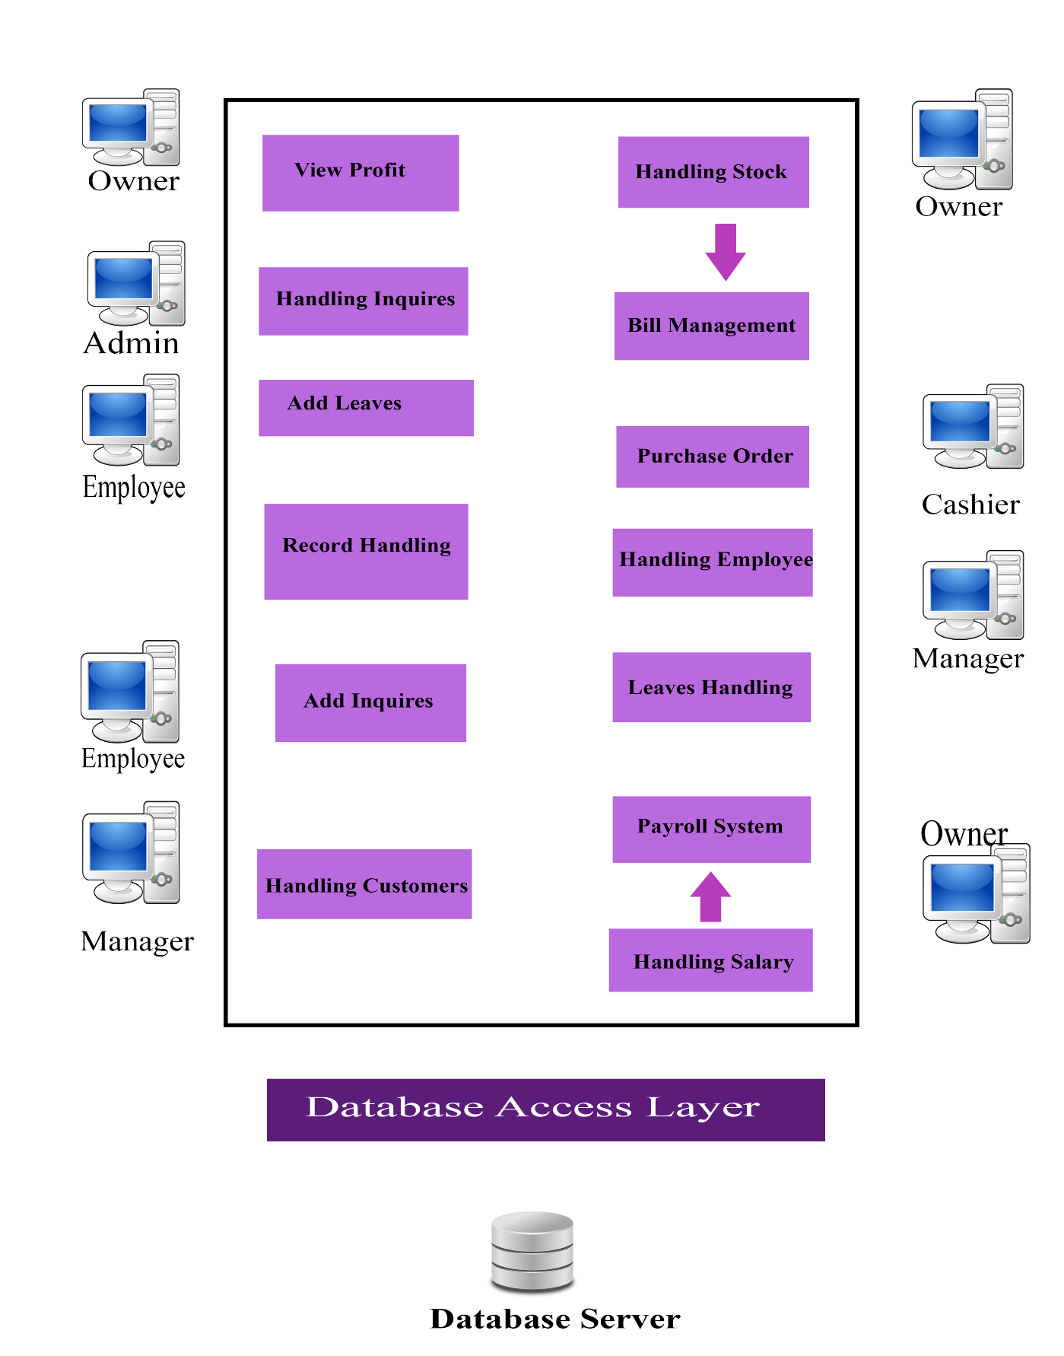

# Objectives

The main objective of Creating the Micro Electronic Shop Management System is to implement all processes and manage the working process in a more efficient way.

This system covers all key processes that are currently followed inside and outside the shop. And this project will automate the manual processes done by the workers in the shop and according to their suggestions this system would be a great help to all the work.

In Micro Electronic Shop Management System, there are different management levels considering the overall process. Such as Product Management, Stock Management, Payroll System, Employee Management, Leaves Management, Customer Management, Salary Management, Admin Management etc.

This system will give benefits through increased efficiency and effectiveness. It also shows the commitment to increased performance, employee and customer satisfaction, and continuous improvement. The Management levels are listed below:

**Product Management**

In this process there are some options that will done by the owner. those are Adding, Removing and Updating items. The owner able to view the wholesale prices of the items. Estimating the Prices are done by the manager. Manager also able to manage items by giving daily discounts for the items.

**Stock Management**

In order to manage stocks owner should be able to use a specific way. Owner able to Add, Remove and Update stocks from the system. manager also able to add stocks to the system. Stock management system that will be implemented will keep track of stocks and alert when a production runs out of the stock. When a customer purchases an order, there must be a deduction form the available items. So that the system will generate an exceed stock report automatically. This exceed stock report can be viewed by the owner and the manager.

**Bill Management**

When a customer purchases an item from the shop there is system called bill management to add that item. It’s done by the cashier. Cashier able to calculate the bill and add to the payment. And there are three option types to take when a customer pays the bill. those are full cash, credit and debit card and check. Cashier able to Update and remove bill. And only the admin can update and remove the payment. Daily reports and monthly reports of sales goes to the admins section.so that the admin able to view them.

**Employee Management**

This is an important section in the system. all the processes depend on employees work. admin will pay their salary according to their working progress. Good employees will be promoted by the manager. Adding, Removing and Updating employees will also done by the manager. Employees able to make and update inquiries which is handled by the Admin.

**Leaves Management**

When an employee wants to get a leave or considering this matter, employee able to add, remove or update leaves. Those leaves will be approved or updated by the manager. And all the leaves and absent dates will count by the system. That data will used by the salary management to calculate the salary for employees. Admin able to create separate user accounts for users when login.

**Salary Management**

Owner and the manager able to Add, Remove and Update bonus for the salary. That data took from the leaves management will be used to generate the salary for employees. Manager creates the salary slip from the calculations and owner can view the salary report. And only the admin can update or delete employee’s salary slip. All the calculations should be correctly done in the system.

**Customer Management**

This system deals with the customers. Manager and cashier take the responsibility to do keep up with system. Adding, Removing and Updating customer will done by cashier. Manager able to view loyalty card details and all the customers details with payments. System will generate back list of customers when they did not pay their installment in particular time period. Customer cannot buy new items without complete their installment that black list. Cashier able to view that black list. Cashier will make loyalty account when customer registered the system**.**

**Admin Management**

When it comes to admin management there are some rules within the system. It’s like a restricted section for the other employees and crew members. All the profit from the shop will be calculated by the admin. Admin gets the inquiries from the crew members and admin able to handle, delete those inquiries. Admin also able to add, update, remove all the functions inside the system.

# Procedure

## **Flow of the Project**

**Requirement Gathering & Analysis**

We are planning to implement a system for the Electronic shop which called “Micro Electronics.” The system should be implemented for the whole shop, which is a wide scope to handle.

Therefore, we visited the client at his shop which is located in Matara. The client provided the details of the procedure of employee management, product management and customer management. That was a great aid for us to organize the sufficient requirements that needs to be in the system.

After gathering the information that we need, to implement the system, the four members of our team gathered together and went through the information we collected from the client, thoroughly.

Once analyzing the client’s problem entirely, we were able to understand what the requirements that we should concentrate on. Then we modularized the system into eight sub-systems, allocated them to each member to develop.

Our “Electronic Shop System” consists of mainly eight functions.

1. Product Management.
2. Stock Management.
3. Payroll System.
4. Employee Management.
5. Leaves Management.
6. Customer Management.
7. Salary Management.
8. Admin Management.

**Designing of the System**

After requirement analysis phase, we will design GUIs of our system. We are planning to provide more simplified and user-friendly interfaces to our client. All GUIs will follow an uncommon look. GUI creation and coding will be created by members for assigned functions using Eclipse IDE.

Next, we will start designing the database. We will create activity diagrams to identify the processes and also the inputs and the outputs of those processes.

**Implementation**

Once we finished the designing phase, the implementation of the system will commence. During the development of the coding, we will use some mechanism to scale down the number of error, which can be occurred when using the system. Mostly field validators will be used to avoid the inconsistency of data, which can be occurred during the insertion of the input. In such case, user friendly error messages will be displayed. After completing a module, the team member will through test their module to eliminate any errors in the code.

The members will do the implementation of the system in isolation as individual modules. This process of implementing the individual modules will approximately last until the sixth week as planned.

**Testing**

Once the implementation and the unit-testing phase is finished, we will start testing of the system. After we find that, each module is error free we will start on integrating the module. Each integrated module will be tested to make sure that it is working properly. Next the fully integrated system will be tested again until the logical and syntax error are eliminating. Then system will be tested for higher and accurate performance once every testing is completed final product will be delivered to the client. After the delivery an acceptance testing will performed by the client to determine whether the product will be accepted or rejected.

## **3.2 Project Plan**

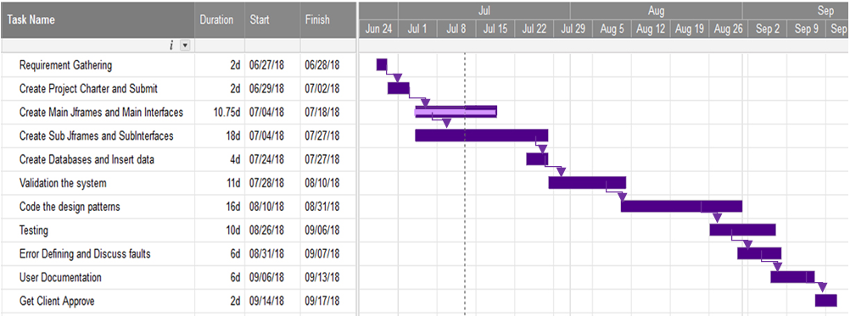This project would take 12 weeks to complete starting before the 2nd of July and in order to accomplish the targets of our project we hope to develop the system and its components in the following order. Before the 2nd of July, we gathered requirements from the client, analyzed them and its components in the following order. Then in 1st of July we started preparing the project charter as well as the presentation which was scheduled on 24th July. In the beginning of the 2nd week, we will start to complete the proposal documentation and we hope to finish the submission of proposal in that week. And also starting from 4th of July system, interface and database design will begin. The above designing phases with design patterns will be completed within the following two weeks. In the beginning of the 7h week we will start to prepare the Progress Evaluation. During 10th week. We are hoping to finish Final Report writing which will be held on the 11th week of the semester. The final product will be presented in the final presentation which will be held in the 12th 13th weeks.

Figure 3.2.a Gantt Chart

# Personal and Functions

|  |  |  |  |
| --- | --- | --- | --- |
|  | **Personal** | **Module** | **Functions** |
| 1. | D.I.K. Rajapakshe | Product Management  Stock Management  Bill Management | * Handling Product * View wholesale price * Handling Stock * View Stock Report * View Exceed Stock Report * Purchase Order and Check available items * Calculate Bill |
| 2. | M.P.P. Shamil | Leaves Management  Salary Management | * Handling Leaves * Add bonus * Handling salaries * Generating salary report * Print salary |
| 3. | Rathnayaka M.H.K.R | Employee Management  Customer Management | * Handling employees * View profile * Set promotions * Handling customers * Set bonus |
| 4. | Subasinghe R.S.R.M.D. | Admin Management | * Handling Inquires * Profit calculation * Rules and regulations * Help page * Handling all the system functions |

# 5.Technologies

For that the technologies we decided to use are Java (JFrame, Application Window and JApplet), Java Swing Designer, MySQL (To connect Windows Builder Pages with the Database) and WAMP Server along with the Tomcat server.

# **Software and Hardware Requirements**

* Our software requires Microsoft Windows 7 ((32-bit or 64-bit) as operating systems.
* As hardware requirements of our software, we require 64-bit machine with a hard disk with at least 1 GB free space.
* Cameleon XP-58 HyperV 58mm Direct Thermal Receipt Printer.
* Epson Inkjet L130 Printer.
* Additionally, 1024X768 16-bit color monitor and a compatible mouse will be required.

# Budget

|  |  |
| --- | --- |
| Transport | Rs. 5,600.00 |
| Cameleon XP-58 HyperV 58mm Direct Thermal Receipt Printer | Rs. 12,900.00 |
| Epson Inkjet L130 Printer | Rs. 21,500.00 |
| Total | Rs. 40,000.00 |

# References

[1] Oracle Corporation, "MySQL :: MySQL 8.0 Reference Manual," dev.mysql.com, July 13 2018. [online]. Available: https://dev.mysql.com/doc/refman/8.0/en/ [Accessed: July. 14, 2018].

[2 Java™ Platform, Standard Edition 8 API Specification "Java," docs.oracle.com. [online]. Available: https://docs.oracle.com/javase/8/docs/api/ [Accessed: July. 14, 2018].

# Appendix A

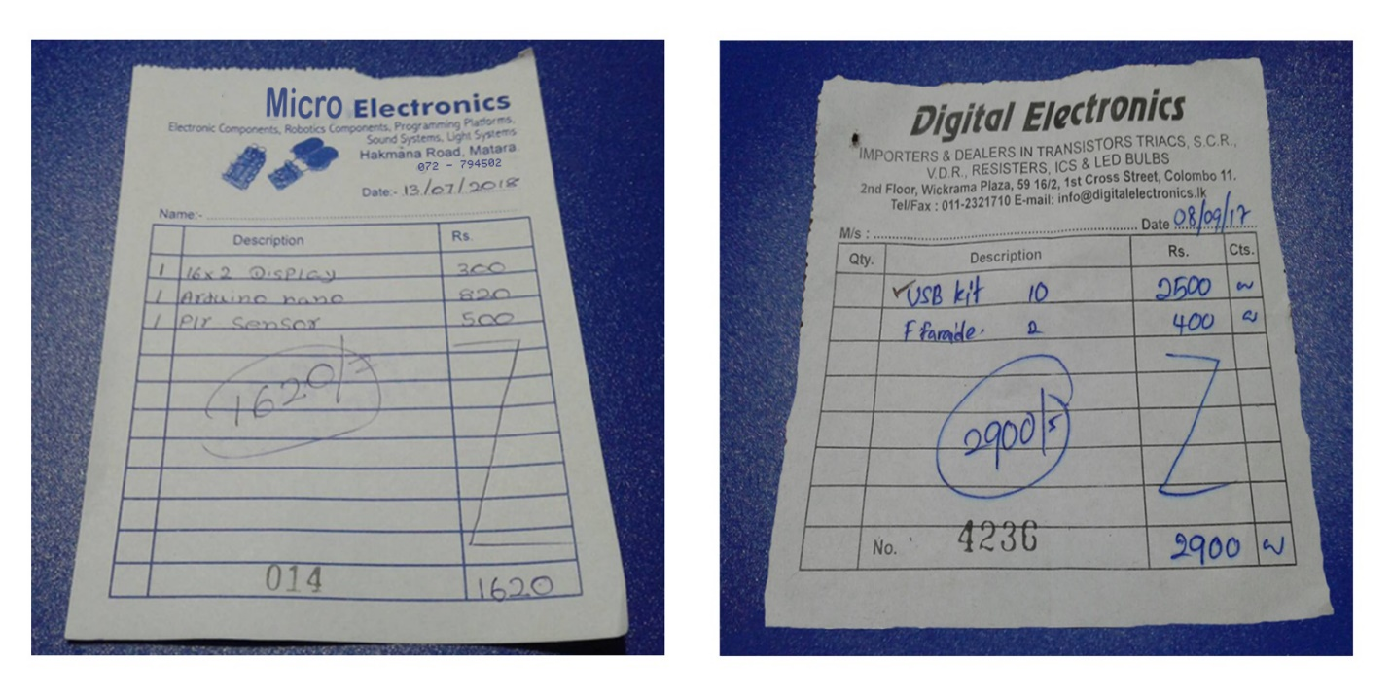

Figure 8.1.a

Purchase order bill Product bill